ASPEA’s team met with teachers with one of the Associated Schools of the project, D. Duarte High School, in Coimbra, to present the project and to talk about the work that will be made with the students. Also, the work to identify the stream to adopt by the school was started, visiting some streams nearby the school.
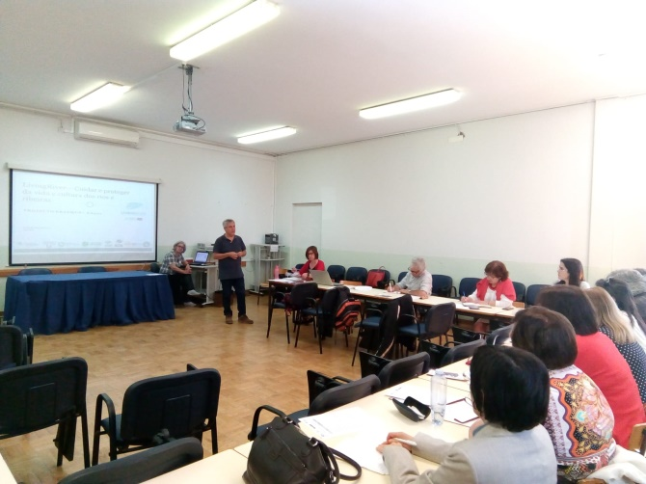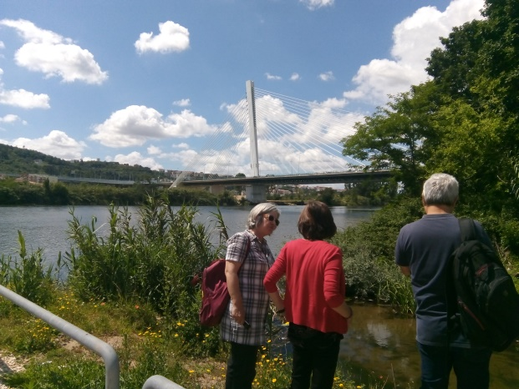

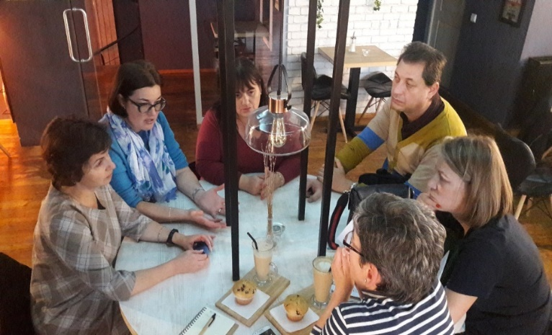
Five romanian teachers are involved and working in the LIVINGRIVER Project from Technical College „Mircea Cristea” and Science College „Grigore Antipa” from Brasov. A brief description of the schools can be found in the project website.
In November took place a meeting with the teachers of the associated schools, who participated in the training course in Coimbra, to plan future activities within the project.

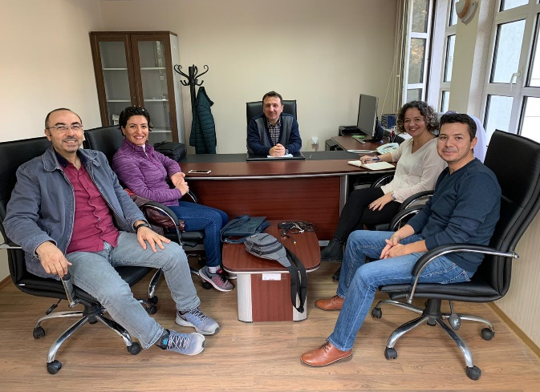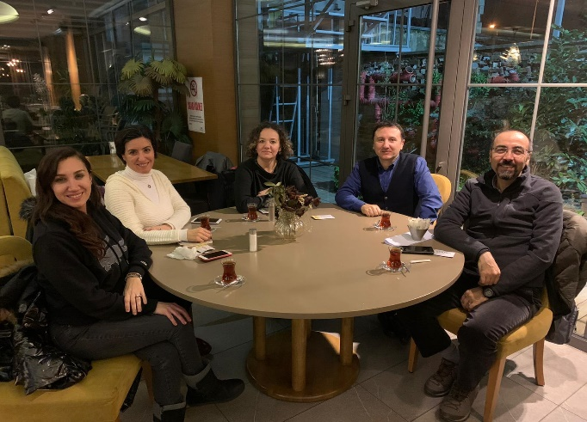
January 07, 2020 – Meeting includes the topics such as planning the activities for students
November 19, 2019 – Meeting includes the strategies student selection and motivation for the aim of the project

