Balıkesir University Multiplier Event
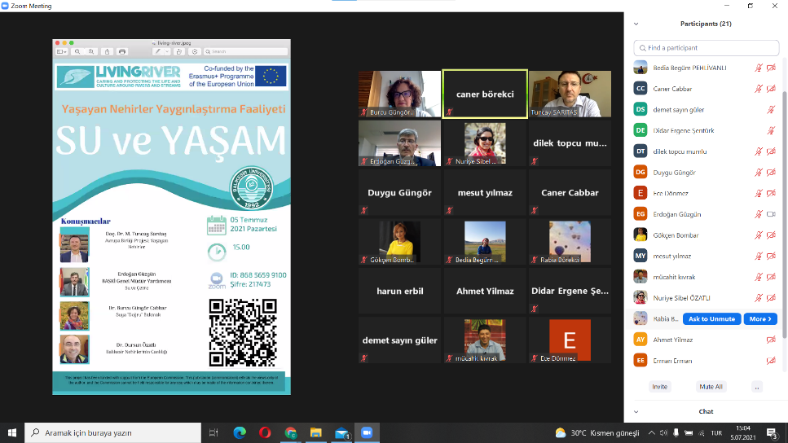
The multiplier event of the “Living Rivers Project, carried out within the scope of the European Union Erasmus+ KA201 strategic partnerships program, of which Balıkesir University is a partner, was held on July 05 2021. 85 participants working in different institutions actively participated in the online event.
In the "Water and Life" themed multiplier event, Assoc. Prof. Dr. M. Tuncay SARITAS, project researchers Dr. Burcu CABBAR GÜNGÖR and Dr. Dursun ÖZATLI informed our participants about the activities carried out within the scope of the project. Dr. Tuncay Sarıtaş gave information about the projects’ intellectual outputs, associated schools and students within the scope of the project, and talked about the contribution of the rivers to the development of culture and the emergence of culture around them.
Dr. Burcu Güngör Cabbar conveyed information about the place and importance of water in our lives, Dr. Dursun Özatlı talked about the work done with the students in the field and in the laboratories to measure the quality of the river. He shared the analyses about the vitality of the rivers with the participants.
